**Abundance and Migration Success of Overshoot Steelhead in the Upper Columbia River**

Andrew R. Murdoch, Kevin See, and Benjamin L. Truscott

Andrew R. Murdoch1 ([Andrew.Murdoch@dfw.wa.gov](mailto:Andrew.Murdoch@dfw.wa.gov)) Washington Department of Fish and Wildlife 600 Capitol Way North, Olympia, Washington 98501, USA

Kevin See ([Kevin.See@biomark.com](mailto:Kevin.See@biomark.com)). Biomark Inc. 2725 Montlake Blvd. East, Seattle, Washington 98112, USA

Benjamin L. Truscott ([Benjamin.Truscott@dfw.wa.gov](mailto:Benjamin.Truscott@dfw.wa.gov)) Washington Department of Fish and Wildlife 600 Capitol Way North, Olympia, Washington 98501, USA

1 Corresponding author: [Andrew.Murdoch@dfw.wa.gov](mailto:Andrew.Murdoch@dfw.wa.gov) 600 Capitol Way North, Olympia, Washington 98501, USA. Phone (509) 664-3148 x278, FAX (509) 662-6606.

*Abstract.* – In response to an altered environment, adult summer steelhead *Oncorhynchus mykiss* may exhibit complex behaviors during upstream migration in the Columbia River Basin. Steelhead may migrate upstream of their natal tributary or overshoot from days to several months and subsequently migrate downstream or fallback to their natal tributary to spawn. An existing Bayesian patch occupancy model that used adult steelhead tagged with passive integrated transponder (PIT) tags to estimate population-specific abundance upstream of the tagging location was modified to also to estimate the abundance of overshoot fallbacks. Overshoot abundance at the tagging location was estimated using the relationship between known fallbacks and their estimated abundance. The annual mean (SD) proportion of overshoot steelhead that successfully migrated downstream of the tagging location (i.e., Priest Rapids Dam) was 0.66 (0.25). The spatial distribution (i.e., number of dams detected upstream of Priest Rapids Dam) of overshoot steelhead suggested the number of dams negatively affected migration success probability. This is the first study to estimate the abundance of overshoot and fallback steelhead and can be replicated using existing models in the Snake River Basin. Studies have consistently shown that surface flow passage routes (e.g., sluiceways and temporary spillway weirs) are very effective in guiding and passing adult steelhead downstream of a hydroelectric project. Overshoot rates are expected to increase (i.e., both magnitude and number of populations) in response to increasing water temperatures. In response, steelhead and to a lesser extent other anadromous salmonids have shown their resilience in adapting to these unfavorable migration conditions. However, without significantly increasing the downstream migration success of both pre-spawn (i.e., overshoot) and post-spawn (i.e., kelts) steelhead, greater uncertainty in the efficacy of recovery efforts in other areas (i.e., habitat, hatchery and harvest) may be the consequence.

Summer steelhead *Oncorhynchus mykiss* in the Columbia River enter freshwater the year prior to spawning. This life history strategy allows for access to spawning habitats a greater distance from the ocean or areas with only seasonal access (i.e., temporary migrations barriers due to low discharge or high temperatures) compared to winter steelhead that enter freshwater the same year as spawning. Adult summer steelhead may enter the Columbia River over an eight month period between March and October (Busby et al. 1996), but peak migration at Bonneville Dam (rkm xxx) occurs during August when water temperatures are near lethal limits (Richter and Kolmes 2005). The effects of Columbia River water temperatures on adult anadromous salmonid migration survival is a concern for fish managers (Keefer et al. 2004). Interior Columbia River summer steelhead populations (i.e., upstream of Bonneville Dam) are at greater risk to climate-change related increases in water temperature in the future (Wade et al. 2013). The physiological effects, both acute and chronic, of elevated water temperatures on salmonids are well studied and include higher metabolic demands, physiological stress, higher prevalence of disease and death. Behavioral effects from elevated water temperatures include delayed migration at hydroelectric dams (Keefer et al. 2004) and temporary use of non-natal tributaries (High et al. 2006).

Due to a prolonged period of freshwater entry and residency prior to spawning, summer steelhead may exhibit complex migration patterns in response to altered freshwater habitat conditions that presumably increase their probability of survival to spawning. Summer steelhead have been shown to temporarily use several non-natal tributaries in the lower Columbia River or areas in the Columbia River immediately downstream (i.e., tributary plume) as cold water refuges (High et al 2006; Keefer et al. 2009; Hess et al 2016; Keefer et al. 2018). Keefer et al. 2009 found that passage time (d) through the Bonneville Dam reservoir increased as a function of water temperature and use of cold water refuges. Steelhead may remain in cold water refuges between 1 h and 237 d (High et al 2006). The spatial extent of non-natal tributary use by steelhead may extend as far upstream as 71 km as was reported in the Deschutes River (Hess et al. 2016). The magnitude of cold water refuge use varies with Columbia River water temperature and has been reported as high 66% for interior Columbia River steelhead and many (37%) may use more than one tributary (High et al. 2006). Summer steelhead from the early part of the run (before Aug 25) used cold water refuges (66%) at a slightly higher rate than later fish for the later (after Aug 25) part of the run. The survival benefits of this behavior are less clear. Keefer et al. (2009) reported that survival of steelhead using cold water refuges was 8% lower (11% hatchery and 5% wild) compared to steelhead that did into use cold water refuges. Higher rates of harvest within the cold water tributaries and possible poor condition were attributed to lower overall survival rates. Regardless, in face of climate change impacts identifying, protecting and maintaining cold water refuges will be important in the lower Columbia River for all anadromous species migrating during periods of increasing water temperatures.

Summer steelhead from some interior Columbia River populations also may exhibit a complex migration pattern referred to overshooting. Overshooting refers to a behavior that involves a steelhead migrating past the mouth of its natal tributary for an undetermined time period, presumably due to high tributary water temperatures, but the probability of returning to their natal stream or “overshoot fallback” is more variable and less understood. This behavior has also been reported in the Columbia River for Chinook Salmon *O. tshawytscha,* but at lower rate than reported for steelhead (Boggs et al. 2004; Keefer et al 2008a; Mann and Snow 2018). Richins and Skalski (2018) reported that overshoot rates of known origin adult steelhead as high as 71% with many populations exhibited rates > 50%. Increasing water temperatures, especially near their natal tributary greatly influenced overshoot rates. Steelhead ocean age, adult ladder placement in relation to the natal tributary, and hatchery practices (i.e., broodstock origin and rearing location) also influenced over shoot rates (Richins and Skalski 2018). Overshoot fallback rates were also highly variable and ranged from 18% to 75% and were positively influenced by the number of days hydroelectric projects spilled water the following March.

Given the variable overshoot fallback rates reported for steelhead, failure to return to their natal tributary or presence in a non-natal tributary (i.e., stray) may have serious conservation implications. While the apparent mortality or cost of temporary using non-natal tributaries as cool water refuges can be reduced, in part, through harvest regulations (Keefer et al. 2009), the spatial distribution of overshoot steelhead may be considerable greater (i.e., not limited to lower river reaches or tributary confluences) and may preclude the use of harvest regulations. More importantly, overshoot steelhead must migrate downstream in order to return to their natal tributary and the only passage route may be through the turbines (Richins and Skalski 2018) which result in high mortality rates (Wertheimer and Evans 2005). Khan et al. (2013) found that downstream migrating adult steelhead greatly prefer surface (e.g., sluiceway) over turbine passage routes. If preferred passage routes are not available steelhead may expend considerable energy searching expending important energy reserves prior to spawning or may simply spawn in a the nearest available stream (i.e., stray). Hence, overshoot steelhead may suffer high mortality trying to return to their natal stream during winter months (i.e., demographic cost to donor population) or spawn in a non-natal stream and have genetic impacts on the recipient population. Given the risks associated with overshoot behavior the goals of this study were to 1) estimate the abundance of overshoot steelhead at Priest Rapids Dam 2) describe migration patterns and distribution of overshoot steelhead upstream of Priest Rapids Dam and 3) estimate the abundance of overshoot steelhead that successfully migrated downstream of Priest Rapids Dam.

**METHODS**

*Study area*. – The Upper Columbia River (UCR) steelhead Distinct Population Segment (DPS) is comprised of four populations and extends upstream from the confluence of the Yakima River to the border with Canada. Steelhead status and trend monitoring for this DPS has been occurring at Priest Rapids Dam since 1986 (Brown 1995). However, adult steelhead tagged with passive integrated transponder (PIT) tags as juveniles from the Middle Columbia River (MCR) and Snake River (SR) DPSs have been observed annually at Priest Rapids Dam (i.e., overshoots) since PIT tag detectors were installed in the fish ladders in 2003 (Figure 1). Richins and Skalski (2018) estimated overshoot and fallback rates of selected populations of steelhead throughout Columbia and Snake River basins but did not report estimates of abundance. Because adult steelhead rarely use adult ladders to migrate downstream, dam counts are positively biased as estimates of escapement upstream because some unknown fraction migrate downstream (i.e., fallback) presumably to their natal tributary prior to spawning.

*Fallback abundance*.– Escapement estimates of the four populations that comprise the UCR DPS have been estimated based on adult steelhead tagged with passive integrated transponder (PIT) tags at Priest Rapids Dam (~15% of the run) that were subsequently detected at instream interrogation sites within each population using a Bayesian nested patch occupancy model (Waterhouse et al. 2019). Complete PIT tag detection histories for each fish tagged at Priest Rapids Dam were queried from the PIT Tag Information System (PTAGIS) database operated by the Pacific States Marine Fisheries Commission (PSMFC 2015). The model estimates movement rates past various detection points while accounting for imperfect detection at those sites. Detection probabilities are estimated through the use of double arrays at some sites, as well as detections from sites upstream of a particular point. When combined with an estimate of total abundance at Priest Rapids Dam, it translates those movement estimates into escapement estimates. Because a number of steelhead overshoot Priest Rapids Dam, fallback, and ascend their natal stream to spawn where their PIT tags are detected, the model structure includes some interrogation sites downstream of Priest Rapids Dam. A majority of downstream sites (PTAGIS site code in brackets) are in the MCR DPS including the Yakima River at rkm 76 (Prosser Dam [PRO]), Walla Walla River at rkm 9 [PRV]), Umatilla River at rkm 5 (Three Mile Falls Dam [TMF]), and the John Day River at rkm 35 (McDonald Ferry site [JD1]). The abundance of steelhead that passed Priest Rapids Dam and fell back to the SR DPS was estimated at Ice Harbor Dam at rkm 16 [IHA]. Relationships between hatchery and wild steelhead fallback abundance were examined using linear regression by comparing the total estimate of fallback abundance from PIT tags with the number of juvenile tags which were inserted as juveniles, and detected as adults at Priest Rapids.

*Overshoot abundance*. – Richins and Skalski (2018) used adult steelhead tagged as juveniles in the natal stream to estimate rates of overshoot and successful fallback. They reported that fallback rates were unrelated to overshoot rates and ranged from 7.7% to 93.4%. Hence, fallback abundance estimates underrepresent the abundance of steelhead that overshot their natal stream.

Estimating overshoot abundance is important because when combined with the abundance of steelhead that did not overshoot their natal tributary represents the total number of adults that returned at least as far as the Columbia River. Therefore, estimates of population abundance and productivity based solely on returns to the subbasin may be negatively biased. The relationship between the abundance of fallbacks estimated from the patch occupancy model (i.e., based on steelhead tagged as adults at Priest Rapids) and the number of steelhead adults tagged as juveniles that were observed at Priest Rapids Dam and subsequently downstream of Priest Rapid Dam (i.e., successful downstream migration) was examined using a linear regression through the origin. We did not estimate an intercept because not only was it not statistically significant (p = 0.50) but a no-intercept model is more realistic biologically. Using that relationship, the abundance of steelhead that overshoot their natal stream and migrated past Priest Rapids Dam was estimated using the total number of known overshoots (tagged as juveniles) observed at Priest Rapids Dam. The fallback-overshoot ratio or conversion rate was calculated annually and incorporated uncertainty from both estimates of fallback and overshoot using the delta method (Doob, J. 1935). All statistical analyses were conducted using R software (R Core Team 2015).

*Overshoot migration success and timing*. – Adult steelhead tagged as juveniles in their natal tributary downstream of Priest Rapids Dam are known overshoot steelhead. Complete detection histories for each fish between 2010 and 2017 were queried from the PTAGIS database in order to examine migration patterns. Because PIT tag detections during downstream migration are limited upstream of Priest Rapids Dam (i.e., only Rocky Reach Dam has a juvenile bypass and closes August 31), the last dam fish were detected during their upstream migration were pooled across years due to low sample sizes and categorized whether fish subsequently observed downstream of Priest Rapid Dam (i.e., before spawning not as kelts). Project specific conversion rates were estimated by dividing by the proportion of overshoot steelhead that were observed downstream of Priest Rapids Dam by the proportion estimated at the downstream project. Because overshoot steelhead that were last detected at Priest Rapids Dam may have also migrated upstream of Wanapum Dam (i.e., joint conversion rate), the conversion rate for each project (i.e., Priest Rapids and Wanapum) was calculated by taking the square root of the observed conversion rate of Priest Rapids/Wanapum Project ($e.g.,\sqrt{X^{2}}=X for each project$).

As a consequence of exhibiting an overshoot behavior, steelhead must migrate further, expend greater amounts of energy and may be in poorer condition when entering their natal tributary. For example, steelhead tagged at Priest Rapids Dam and subsequently detected at Prosser Dam in the lower Yakima River must migrate a minimum of 200 km (100 km each way) more than fish that entered the Yakima River directly. The influence of overshoot and fallback on run timing into their natural tributary was examined at Prosser Dam by expanding steelhead PIT tag detections from Priest Rapids, at a monthly time scale, using an average tag rate of 15%. The estimated monthly abundance of overshoot steelhead was compared to non-overshoot steelhead using a Kolmogorov-Smirnov (KS) test. Mean monthly water temperature in the lower Yakima River were queried from the U.S, Bureau of Reclamation Hydromet station at Kiona ([https://www.usbr.gov/pn/hydromet/yakima/yakwebarcread.html](https://www.usbr.gov/pn/hydromet/yakima/yakwebarcread.html%20)) and Columbia River from the tailrace of Priest Rapids Dam Data Access Real time (DART) website (http://www.cbr.washington.edu/dart/query/river_daily

**RESULTS**

Fallback estimates from Priest Rapids Dam averaged 20% (range 12-31%) and 15% (range 9-22%) of the adjusted Priest Rapids Dam steelhead count for wild and hatchery steelhead, respectively (Table 1). Wild and hatchery steelhead abundance was significantly related (R2 = 0.53, *P* < 0.04) suggesting factors influencing abundance affected both wild and hatchery steelhead similarly. The largest group of fallback steelhead were observed in the Snake River at Ice Harbor Dam followed by the Yakima River at Prosser Dam (Table 2). Other overshoot populations in the MCR DPS were less abundant consistent with that reported by Richins and Skalski (2018). Because population-specific annual PIT tagging rates of juvenile wild steelhead are likely variable and unknown, we examined the relationship between the annual total estimated fallback abundance from the patch occupancy model and the total number of adult steelhead tagged as juveniles that were detected at Priest Rapid Dam and as overshoot fallbacks. The estimated total overshoot fallback abundance of wild steelhead was significantly related to the number of known overshoot fallbacks (R2 = 0.78, *P* < 0.001). Hatchery steelhead were not included in this relationship because harvest rates both upstream and downstream of Priest Rapids Dam are variable and unknown. Using this relationship, we estimated the total overshoot abundance of wild steelhead at Priest Rapids Dam based on the total number of known overshoots;

Overshoot abundance = 44.651*x*

where *x* is the number of known overshoot adult steelhead PIT tagged as juveniles detected downstream of Priest Rapids Dam (Table 3). Wild steelhead overshoots comprised an average of 34% (SD = 16%) of the adjusted Priest Rapids Dam count and ranged between 14% and 67%. The downstream migration success rate or conversion rate of wild steelhead was estimated as the proportion of overshoot steelhead that were estimated as fallbacks (Table 3). Conversion rates of wild steelhead were also variable and averaged 66% (SD = 25%), but annual conversion rate were relatively precise (Mean coefficient of variation [CV] = 14%; range 11% to 17%).

The plurality of known wild steelhead overshoots (46%) were last detected at Priest Rapids Dam (Figure 2). However, it is likely that some of these fish migrated upstream of Wanapum Dam, but there are no PIT tag detectors in the adult ladders. Conversely, most unsuccessful overshoot steelhead were last detected at Wells Dam (15%). Overall, the proportion of known overshoot steelhead that were detected downstream of Priest Rapids Dam (69%) was similar to the estimated mean conversions rate (66%). A proportion of known overshoot steelhead were last detected in tributaries (16%), primarily upstream of Wells Dam (80%), were typically observed in a tributary upstream of the last dam in which they were detected (93%). A majority if wild steelhead overshoots entered tributaries after January 1 (73%) presumably as part of their spawning migration. A similar trend was observed for overshoot hatchery steelhead where only 14% were in observed in tributaries. Of those, 95% were in a tributary upstream of the last dam in which they were detected and 64% were detected in the spring. Although tributary observations were not adjusted for detection probabilities and should be considered minimum estimates, it is worth noting that 100% of the wild steelhead and 79% of the hatchery steelhead detected in the spring were last detected in known spawning areas.

Individual project conversion rates for the Priest Rapids and Wanapum Projects (i.e., the square root of the Priest/Wanapum conversion rate 0.88) was estimated at 0.94. When fish last observed in a tributary (N = 15) were included, the mean project conversion rate increased from 78% to 86% (Figure 3) and was less variable (CV decreased from 27% to 5%).

The relative prevalence of the overshoot behavior and influence of migration timing into their natal tributary was examined using Yakima River steelhead. Between 2010 and 2017, 327 wild steelhead tagged as juveniles were detected at McNary Dam. Of those, 13% were detected at Priest Rapids Dam and 3% at Ice Harbor Dam consistent with that reported by Richins and Skalski (2018). Of those, a small percentage (2%) were detected at both Priest Rapids and Ice Harbor dams. Yakima steelhead that were not detected at a Columbia or Snake River dam upstream of McNary Dam had the greatest proportion detected at Prosser Dam (95%). Overshoot steelhead at Priest Rapids Dam and Ice Harbor Dam had conversion success rates of 78% and 60%, respectively. Based on detections of steelhead PIT tagged at Priest Rapids Dam at Prosser Dam, overshoot steelhead migrated into the Yakima River between late fall and spring also consistent with that reported by Richins and Skalski (2018). However, based on the estimated number of overshoot steelhead significant differences in migration timing were found when compared to fish that did not overshoot (KS test; *P* < 0.001; Figure 4). While both groups of steelhead initiated their upstream migration once the Yakima River water temperatures were similar to the Columbia River, 50% of overshoot steelhead entered the Yakima Basin prior to January 1 compared to 75% of non-overshoot steelhead.

**DISCUSSION**

The estimated annual mean (SD) number of wild and hatchery steelhead that fell back over Priest Rapids Dam during the study period was 916 (620) and 1,496 (678), respectively. Of steelhead passing Priest Rapids Dam, the mean proportion (CV) of fallbacks was 0.1979 (28%) and 0.1485 (32%) for wild and hatchery steelhead, respectively. An adult steelhead radio telemetry study conducted in 2015 and 2016 reported similar levels of fallback (Fuchs et al. 2019). In that study, radio tag-based estimates of fallback generally estimated higher fallback compared to PIT tag-based model estimates, presumably due to a smaller sample size. While these estimates were generated using different tag types, it should be noted that all radio tagged steelhead were also PIT tagged and included in the patch-occupancy model estimates. Mean (SD) annual estimates of overshoot wild and hatchery steelhead at Priest Rapids Dam were 1,385 (685) and 1,860 (816), respectively. Overshoot wild and hatchery steelhead comprised 34% and 19% of the Priest Rapids Dam count and was more variable (wild CV = 47%; hatchery CV = 39%) than estimates of fall back. These data suggest that dam counts may not represent the status and trend of upstream populations and methodologies that use dam counts must account for complex migration patterns (e.g., Buchanan and Skalski 2010; Waterhouse et al. 2019).

Estimates of overshoot abundance in this study were based on the relationship between known overshoot fallbacks and fallback abundance estimates. Variability in annual PIT tagging rates of juvenile steelhead from any single population or subbasin required pooling of data thereby reducing the sample size used in the regression model (N = 8). Ideally, similar PIT tagging rates from all potential overshoot populations would increase the sample size and potentially allow for population-specific relationships or relationships based on a similar number of dams required to fallback. Conversion rates of wild steelhead generated for this study (mean = 66%) were similar to conversion rate based on known overshoots (69%) suggesting that approximately 1 out every 3 overshoot steelhead do not successfully fallback downstream of Priest Rapids Dam. Of those known overshoot steelhead that did not successfully fallback only 16% (N =15) were last observed in tributaries. While the proportion of fish last observed in tributaries was not adjusted for detection probability, an instream PIT tag detection system (IPDS) is installed in every major and minor spawning stream upstream of Rock Island Dam with a mean (SD) detection probability of 0.894 (0.132) with a range from 0.505 to 0.999 (Waterhouse et al. 2019). While several potential minor spawning areas are not monitored using IPDSs (Fuchs et al. 2019), we assumed the most unsuccessful overshoot steelhead suffered either natural mortality or were killed during downstream migration from turbine strikes. On August 31, summer spill programs and juvenile bypasses are shut down for the season because the juvenile outmigration period has ended. Unfortunately, this coincides with the period when overshoot steelhead initiate their downstream migration back to their natal streams (Fuchs et al. 2019). Downstream survival rates of adult salmonids via turbine passage are largely unknown, but decrease as fish length increases (Coutant and Whitney 2000).

The spatial patterns of known overshoots (i.e., successful versus unsuccessful) upstream of Priest Rapids Dam suggest the number of dams is an important factor. The largest proportion of fallbacks were last observed at Priest Rapids Dam (i.e., one or two dams because Wanapum Dam has no PIT detection) and the largest proportion of overshoot steelhead were last observed at Wells Dam (i.e., five dams). Project specific conversion rates generally declined as fish migrated farther upstream. As migration distance, migration duration, and number of migration obstacles (i.e., dams) increased, fish condition was likely negatively affected which also likely contributed in lower rates of migration success (Caudill et al. 2007). As a result of an extended migration distance and duration, overshoot steelhead that fallback and arrive at their natal stream may have deleted energy reserves and exhibit greater rates of prespawn mortality or lower spawning success (Mann et al. 2009) and less likely to return as repeat spawners (Keefer et al. 2008b).

Summer steelhead in the Columbia River Basin exhibit at least two different behaviors (i.e., use of cool water refuges and overshooting) in response to elevated water temperatures, but have potentially different consequences related to both migration delays and success. Steelhead that use temporary cold water refuges in the lower Columbia River during their upstream migration were typically delayed between two weeks and two months, and the higher wild steelhead mortality (4.5 percentage points) was attributed to harvest (Keefer et al. 2009). In that study, permanent straying (i.e., spawning in a non-natal stream) could not be differentiated from steelhead that were harvested within the cool water refuges. Conversely, wild steelhead that overshoot their natal stream and migrate upstream of Priest Rapids Dam are not subject to direct harvest, but are subject to indirect mortality from recreational fisheries not to exceed 2% (NMFS 2003). Hence, differences in migration success between overshoot and non-overshoot Yakima steelhead (16.9 percentage points) are more likely not associated with harvest. Furthermore, delays in migration are considerably longer compared to fish using cool-water refuges. For example, the average (SD) number days from when Yakima River steelhead were detected at Priest Rapids Dam and subsequently at Prosser Dam was 138 (73). These data suggest that the overshooting behavior of some steelhead population has greater impacts on population viability (i.e., abundance and productivity) than steelhead that don’t overshoot or those that use cool water refuges.

Overshoot and fallback rates have been estimated for many populations in the Columbia River Basin (Richins and Skalski 2018). While several factors were shown to influence overshoot rates (i.e., natal stream water temperature, hatchery rearing location, adult ladder placement, and ocean age) and many results are consistent with this study, abundance estimates of overshoot and fallback were not reported and a comparison of migration success of the two basic overshoot pathways (upstream of Priest Rapids or Ice harbor dams) was not conducted. While a majority of the estimated overshoot wild steelhead at Priest Rapids Dam were from the SR DPS (53%), the remainder were from the MCR DPS (47%). The MCR DPS is located downstream of Priest Rapids Dam and Ice Harbor Dam (except the Yakima) and is comprised of 4 major population groups (MPG) and 20 independent steelhead populations. Of which, steelhead from five subbasins (John Day, Umatilla, Walla Walla, Touchet and Yakima) are routinely observed as overshoots at Priest Rapids and Ice Harbor dams. For comparison purposes only, we assumed the relationship between known overshoots detected at Priest Rapids Dam and estimated abundance is valid for the lower Snake River.

The composition of wild steelhead overshoots from the MCR DPS detected at Priest Rapids and Ice Harbor dams between 2010 and 2017 were different and consistent with that reported by Richins and Skalski (2018). The majority of MCR DPS steelhead detected at Priest Rapids Dam were from the Yakima River (53%), but were the least abundant (6%) of those detected at Ice Harbor Dam (Figure 4). More importantly, the overall abundance of known overshoot steelhead from the MCR DPS was 523% greater at Ice Harbor Dam (Figure 5). However, because PIT tag detectors were only installed at Little Goose and Lower Monumental dams in 2014, we only examined overshoot patterns and migration success for steelhead returning in 2015. Overshoot patterns in the Snake River were very similar to that in the Upper Columbia River with the greatest proportion of unsuccessful overshoots last detected at Lower Granite Dam (34%) and the greatest proportion of successful overshoot fallbacks observed at Ice Harbor Dam (12%). The conversion rate in the Snake River was 32% compared to 71% in the UCR using the same methodology suggest approximately 2 out 3 MCR DPS steelhead that were detected at Ice Harbor Dam did not return to their natal stream. Furthermore, 40% of the MCR DPS steelhead that were not observed downstream of Ice Harbor Dam were last detected in a spawning stream. In addition, unlike the areas upstream of Priest Rapids Dam, some major potential spawning areas (e.g., lower Grande Ronde and lower Salmon rivers) and some unknown number of minor spawning areas do not have IPDS and may have gone undetected. In summary, compared to overshoot fish upstream of Priest Rapids Dam, over 5 times more MCR steelhead overshoot into the Snake River. Of which, only half as many may successfully fallback and of those unsuccessful steelhead a large proportion may be spawning with fish from the SR DPS. The differences in migration success and magnitude of overshoot steelhead from the MCR DPS should be of great concern for managers. The potential effects of genetic introgression of fish from the MCR DPS spawning with fish from the SR DPS is also problematic. This potential level of genetic introgression may explain, in part, the genetic patterns observed by Blankenship et al. (2011). In that study, MCR DPS populations that did not exhibit strong overshooting behavior (i.e., Klickitat and Big White Salmon) were clustered (aggregate 3) from the rest of the DPS (aggregate 4). Conversely, some MCR DPS populations were also clustered together with UCR DPS and SR DPS populations (i.e., potential spawning areas of overshoot steelhead from the MCR DPS) forming the largest cluster (aggregate 5) in the Columbia-Snake River Basin.

**Management Implications**

Quantifying steelhead overshoot and fallbacks upstream of Priest Rapids Dam assists in defining and prioritizing the issues associated with the downstream movement of prespawn steelhead. However, preliminary data suggest that in the Snake River overshoot steelhead are more than 5 times more abundant and conversions rate may only be 50% of those observed in the Upper Columbia River. Researchers in both the Upper Columbia and Snake rivers use a similar patch occupancy model to estimate population abundance upstream of Priest Rapids and Lower Granite dams, respectively (Orme and Kinzer 2018;Waterhouse et al 2019). An important first step in fully defining the issue of overshoot steelhead in the Columbia-Snake River Basin is to expand the model currently being used at Lower Granite Dam to include more downstream detection sites and perform a similar analysis in order to estimate conversion rates in the lower Snake River.

Climate change scenarios coupled with observed warming of Columbia River water temperatures (Quinn and Adams 1996; ISAB 2007; Crozier et al 2008; Isaak et al. 2018)) suggests higher rates of overshoot from an ever greater number of populations should be expected in the future. As a result of relatively low conversion rates, prolonged migration periods, potential effects from genetic introgression, steelhead overshooting their natal stream, in response to elevated water temperatures or other factors, negatively affect population abundance and productivity. Many studies have consistently shown that both overshoot steelhead (Khan et al. 2013) and kelts (Wertheimer and Evans 2005; Wertheimer 2007; Ham et al. 2015; Harnish et al. 2015) prefer surface flow downstream passage routes (i.e., spillway weirs or sluiceways) which also provide high survival rates. Experiments conducted to evaluate the efficacy of sluiceways (Khan et al. 2013) and temporary spillway weirs (Ham et al. 2015) operated during non-spill periods (i.e.. late fall through winter) found that surface flow passage routes significantly reduced turbine passage while increasing total steelhead passage.

In summary, surface flow downstream passage routes on all 9 Columbia River and 4 lower Snake River hydroprojects should be operated from September 1 through December 15 and from March 1 through April 1 (or the start of spring spill programs) in order to maximize passage efficiency of overshoot fallback steelhead. Lower Columbia River hydroprojects may need to operate downstream surface flow passage routes the entire non-spill period. Additionally, operation of surface flow passage during spills periods through the end of June would also increase the passage efficiency of kelts. Following the completion of a similar analysis in the Snake River, the potential benefit, in terms of population viability, resulting from higher downstream passage efficiency throughout the Columbia-Snake River basin by both pre-spawn and post-spawn steelhead can be estimated using existing models (e.g., population viability or life cycle models). Furthermore, existing monitoring programs at Priest Rapids and Lower Granite dams will provide annual estimates of conversion rates and serve as a low-cost effectiveness monitoring tool. While the recommendations from the study conducted at The Dalles Dam have been implemented (Khan et al 2013), all the steelhead populations exhibiting high rates of overshoot are upstream of The Dalles Dam (Richins and Skalski 2018).

**ACKNOWLEDGMENTS**

This research was funded by Bonneville Power Administration under Project #2010-034-00. We would like to thank Janet Eckenberg for leading tagging operations at Priest Rapids Dam and Jay Deason, Matt Stilwater, Garret Rains, David Grundy and numerous other technicians for constructing, installing and maintain the IPDS infrastructure upstream of Priest Rapids Dam. We would also like to thanks Grant County PUD for providing access to the Off Ladder Adult Fish Trap (OLAFT) at Priest Rapids Dam for over 30 years and Chelan County PUD for providing PIT tags for adult steelhead.

Table 1. Steelhead abundance (adjusted for ladder fallback) at Priest Rapids Dam and the estimated number of fallback steelhead using the patch occupancy model, 2010-2017.

|  |  |  |  |  |  |  |  |  |  |
| --- | --- | --- | --- | --- | --- | --- | --- | --- | --- |
| Run Year | Adjusted Priest Rapids Dam Count | |  | Estimated overshoot fallback abundance | | | | | |
| Wild | Hatchery | Wild | | | Hatchery | | |
| Estimate | Lower 95% CI | Upper 95% CI | Estimate | Lower 95% CI | Upper 95% CI |
| 2010 | 7,295 | 17,918 |  | 1,652 | 1,411 | 1,915 | 1,532 | 1,265 | 1,765 |
| 2011 | 4,705 | 15,291 |  | 755 | 611 | 901 | 1,757 | 1,546 | 1,973 |
| 2012 | 3,119 | 13,201 |  | 552 | 432 | 675 | 1,909 | 1,694 | 2,115 |
| 2013 | 4,954 | 9,193 |  | 1,068 | 89 | 1,214 | 1,586 | 1,393 | 1,775 |
| 2014 | 6,326 | 12,277 |  | 1,945 | 1,764 | 2,153 | 2,705 | 2,492 | 2,952 |
| 2015 | 4,560 | 9,239 |  | 874 | 747 | 998 | 1,003 | 871 | 1,135 |
| 2016 | 1,423 | 4,765 |  | 267 | 203 | 333 | 969 | 852 | 1,094 |
| 2017 | 1,855 | 3,634 |  | 217 | 162 | 283 | 503 | 419 | 598 |

Table 2. Estimates by subbasin and PTAGIS code of overshoot fallback steelhead downstream of Priest Rapids Dam. (PRO = Prosser Dam; ICH = Ice Harbor Dam; PRV = Pierce RV Park instream array; TMF = Three Mile Falls Dam; JD1 = Lower John Day at McDonald Ferry). Parentheses indicate PIT tag detection probability (mean, SD). W = wild and H = hatchery.

|  |  |  |  |  |  |  |  |  |
| --- | --- | --- | --- | --- | --- | --- | --- | --- |
| Run Year | Yakima  PRO  (0.96, 0.02) | Snake  ICH  (1.0, 0.01) | | Walla Walla  PRV  (0.57, 0.39) | | Umatilla  TMF  (0.75,0.46) | | John Day  JD1  (0.59, 0.37) |
| W | W | H | W | H | W | H | W |
| 2010 | 840 | 690 | 1,397 | 55 | 0 | 33 | 23 | 0 |
| 2011 | 364 | 363 | 1,698 | 21 | 0 | 0 | 0 | 0 |
| 2012 | 181 | 324 | 1,832 | 20 | 14 | 13 | 0 | 0 |
| 2013 | 334 | 639 | 1,433 | 19 | 51 | 19 | 13 | 38 |
| 2014 | 579 | 1,169 | 2,504 | 75 | 27 | 53 | 22 | 43 |
| 2015 | 324 | 426 | 882 | 57 | 20 | 24 | 0 | 29 |
| 2016 | 89 | 117 | 685 | 20 | 26 | 12 | 0 | 20 |
| 2017 | 116 | 65 | 254 | 12 | 9 | 0 | 0 | 21 |
| Mean | 353 | 474 | 1,336 | 35 | 18 | 19 | 7 | 19 |

Table 3. Estimated abundance of overshoot steelhead at Priest Rapids Dam and the conversion rate or proportion of fish observed downstream of Priest Rapids Dam prior to spawning.

|  |  |  |  |  |  |  |  |
| --- | --- | --- | --- | --- | --- | --- | --- |
| Run Year | Estimated wild steelhead overshoot abundance | | |  | Conversion rate  (# fallbacks/# of overshoots) | | |
| Estimate | Lower 95% CI | Upper 95% CI |  | Estimate | Lower 95% CI | Upper 95% CI |
| 2010 | 2368 | 1797 | 2940 |  | 0.6776 | 0.5195 | 0.8758 |
| 2011 | 804 | 610 | 998 |  | 0.9390 | 0.6772 | 1.2009 |
| 2012 | 1385 | 1051 | 1719 |  | 0.3986 | 0.2808 | 0.5163 |
| 2013 | 1787 | 1356 | 2219 |  | 0.5976 | 0.4481 | 0.7472 |
| 2014 | 1966 | 1492 | 2441 |  | 0.9893 | 0.7686 | 1.2100 |
| 2015 | 1564 | 1186 | 1941 |  | 0.5620 | 0.4228 | 0.7013 |
| 2016 | 938 | 712 | 1165 |  | 0.2846 | 0.1933 | 0.3760 |
| 2017 | 268 | 203 | 333 |  | 0.8134 | 0.5356 | 1.0913 |

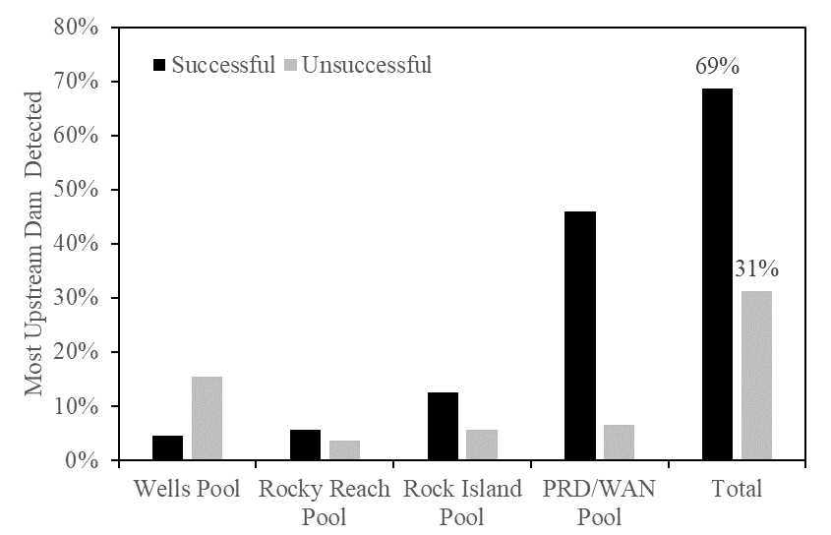

Figure 2. Distribution of known overshoot wild steelhead upstream of Priest Rapids Dam, 2010-2017.

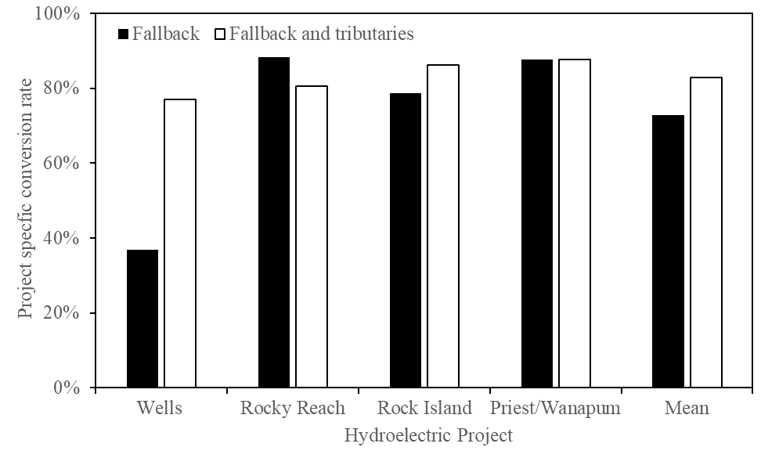

Figure 3. Conversation rates of known overshoot wild steelhead upstream of Priest Rapids Dam, 2010-2017.

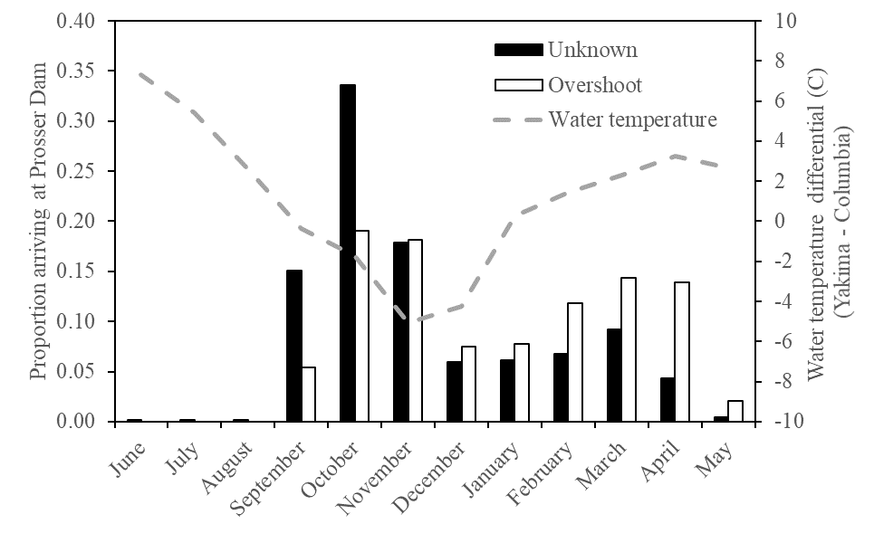

Figure 4. Passage timing of steelhead at Prosser Dam in the lower Yakima River and mean month Yakima River water temperature difference relative to the Columbia River at Priest Rapids Dam tailrace.

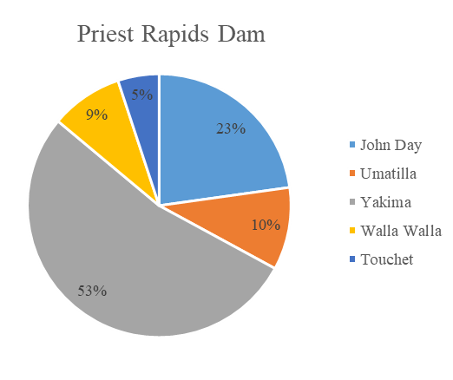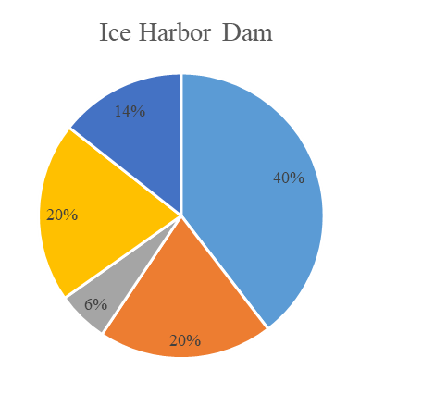

Figure 4. Composition of known overshoot wild steelhead from the Middle Columbia DPS at Priest Rapids and Ice Harbor dams, 2010 – 2017.

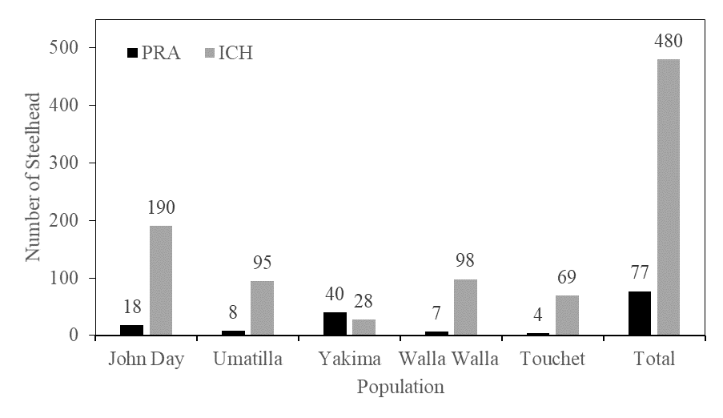

Figure 5. Summary of PIT tagged adult natural origin steelhead from Middle Columbia River DPS observed at Priest Rapids (PRA) and Ice Harbor (ICA) dams, 2010-2017.

References

Blankenship, S. M., M. R. Campbell, J. E. Hess, M. A. Hess, T. K. Kassler, C. C. Kozfkay, A. P. Matala, S. R. Narum, M. M. Paquin, M. P. Small, J. J. Stephenson, and K. I. Warheit. 2011. Major lineages and metapopulations in Columbia River *Oncorhynchus mykiss* are structured by dynamic landscape features and environments. Transactions of the American Fisheries Society 140:665–684.

Boogs, C.T., M.L. Keefer, C.A. Peery, and T.C. Bjornn. 2004. Fallback, reascension, and adjusted fishway escapement estimates for adult Chinook salmon and steelhead at Columbia and Snake River dams. Transactions of the American Fisheries Society 133:932-949.

Brown, L. G. 1995. Mid-Columbia River summer steelhead stock assessment: A summary of

the Priest Rapids steelhead sampling project 1986-1994 cycles. WA. Dep. Fish Wild.

Progress Report Number AF95-02, 85 p.

Buchanan, R. A., and J. R. Skalski. 2010. Using multistate mark-recapture methods to model adult salmonid migration in an industrialized river. Ecological Modelling 221:582–589.

Busby, P. J., Wainwright, T. C., Bryant, G. J., Lierheimer, L. J., Waples, R. S., Waknitz, F. W., and Lagomarsino, I. V. (1996). Status review of west coast Steelhead from Washington, Idaho, Oregon, and California. US Department of Commerce, National Oceanic and Atmospheric Administration, National Marine Fisheries Service, Northwest Fisheries Science Center, Coastal Zone and Estuarine Studies Division.

Caudill, C. C., W. R. Daigle, M. L. Keefer, C. T. Boggs, M. A. Jepson, B. J. Burke, R. W. Zabel, T. C. Bjornn, and C. A. Peery. 2007. Slow dam passage in Columbia River salmonids associated with unsuccessful migration: delayed negative effects of passage obstacles or condition-dependent mortality? Canadian Journal of Fisheries and Aquatic Sciences 64:979–995.

Crozier, L. G., A. P. Hendry, P. W. Lawson, T. P. Quinn, N. J. Mantua, J. Battin, R. G. Shaw, and R. B. Huey. 2008. Potential responses to climate change in organisms with complex life histories: evolution and plasticity in Pacific salmon. Evolutionary Applications 1:252–270.

Coutant, C.C., and R.R. Whitney. 200. Fish behavior in relation to passage through hydropower turbines: a review. Transactions of the American Fisheries Society 129:351-380.

Doob, J.L. 1935. The limiting distributions of certain statistics. The Annals of Mathematical Statistics 6(3):160–169.

Fuchs, N.T., C.C. Caudill, A.R. Murdoch and B.L. Truscott. 2019. Overwintering distribution and post-spawn survival steelhead in the Upper Columbia River basin. North American Journal of Fisheries Management XXX: XXXXXX

Ham, K.D., R.P. Mueller, and P.S. Titzler. 2015. Evaluation of adult steelhead passage with TWS spill during the winter of 2014-2015 at McNary Dam. Pacific Northwest National Laboratory, Richland, Washington.

Harnish, R. A., A. H. Colotelo, X. Li, K. D. Ham, and Z. Deng. 2015. Factors affecting route selection and survival of steelhead kelts at Snake River dams in 2012 and 2013. Pacific Northwest National Laboratory, Richland, Washington.

Hess, M.A., J.E. Hess, A.P. Matala, R.A. French, C.A. Steele, K.C. Lovtang, and S.R. Narum. 2016. Migrating adult steelhead utilize a thermal refuge during summer periods with high water temperatures. ICES Journal of Marine Sciences 73:2616-2624

High B., C.A. Peery, and D.H. Bennett. 2006. Temporary staging of Columbia River summer steelhead in coolwater areas and its effect on migration rates. Transactions of the American Fisheries Society 135:519 -528.

Isaak D.J., C.H. Luce, D.L. Horan, G. Chandler, S. Wollrab, and N.E.Nagel. 2018. Global warming of salmon and trout rivers in the Northwestern U.S.: road to ruin or path through purgatory? Transactions of the American Fisheries Society 147:566-587.

ISAB (Independent Scientific Advisory Board). 2007. Climate change impacts on Columbia River Basin fish and wildlife, p.136. Northwest Power and Conservation Council, Columbia River Basin Indian Tribes, National Marine Fisheries Service, Portland, Oregon.

Khan, F., I.M. Royer., G.E. Johnson, and S.C. Tackley. 2013. Sluiceway operations for adult steelhead downstream passage at The Dalles Dam, Columbia River, USA. North American journal of fisheries management, 33(5), 1013-1023.

Keefer, M. L., C.T. Boggs, C.A. Peery, and C.C. Caudill. 2008a. Overwintering distribution, behavior, and survival of adult summer Steelhead: variability among Columbia River populations. North American Journal of Fisheries Management, 28(1), 81-96.

Keefer, M.L., T.S. Clabough, M.A. Jepson, E.L. Johnson, C.A. Peery, and C.C Caudill, C.C., 2018. Thermal exposure of adult Chinook salmon and steelhead: diverse behavioral strategies in a large and warming river system. PLOS ONE 13(9), e0204274.

Keefer, M. L., C.A. Peery, T.C. Bjornn, M.A. Jepson, and L.C. Stuehrenberg. 2004. Hydrosystem, dam, and reservoir passage rates of adult Chinook salmon and Steelhead in the Columbia and Snake rivers. Transactions of the American Fisheries Society, 133(6), 1413-1439.

Keefer, M. L., C.A. Peery, and B. High. 2009. Behavioral thermoregulation and associated mortality trade-offs in migrating adult Steelhead (*Oncorhynchus mykiss*): variability among sympatric populations. Canadian Journal of Fisheries and Aquatic Sciences, 66(10), 1734-1747.

Keefer, M. L., R.H. Wertheimer, A.F. Evans, C.T. Boggs, and C.A. Peery. 2008b. Iteroparity in Columbia River summer-run Steelhead (*Oncorhynchus mykiss*): implications for conservation. Canadian Journal of Fisheries and Aquatic Sciences, 65(12), 2592-2605.

Mann, R.D., C.A. Peery, A.M. Pinson, C.R. Anderson. 2009. Energy use, migration times, and

spawning success of adult spring–summer Chinook salmon returning to spawning areas in the South Fork Salmon River in Central Idaho: 2002–2007. Technical Report 2009-4.

Cooperative Fish and Wildlife Research Unit, University of Idaho, Moscow.

Mann, R.D., and C.G. Snow. 2018. Population-specific migration patterns of wild adult summer-run Chinook salmon passing Wells Dam, Washington. North American Journal of Fisheries Management 38:377-392.

NMFS (National Marine Fisheries Service). 2003. Biological Opinion and Magnuson-Steve Fishery Conservation Management Act on Issuance of Permit 1395 jointly to WDFW, Chelan PUD, and Douglas PUD, Issuance of Permit 1396 to the USFWS, and Issuance of Permit 1412 to the Confederated Tribes of the Colville Reservation. National Marine Fisheries Service. Seattle, Washington. 87 p.

Orme, R., and R. Kinzer. 2018. Integrated in-stream PIT tag detection system operations and maintenance; PIT tag based adult escapement estimates for spawn years 2016 and 2017. Nez Perce Tribe Department of Fisheries Resources Management, McCall, Idaho.

(Pacific States Marine Fisheries Commission). 2015. PTAGIS (Columbia River Basin PIT Tag Information System) [online database]. PSMFC, Portland, Oregon. Available: www.ptagis.org. (February 2019).

Quinn, T. P., and D. J. Adams. 1996. Environmental changes affecting the migratory timing of American shad and sockeye salmon. Ecology 77:1151–1162.

R Core Team. 2015. R: A Language and Environment for Statistical Computing. R Foundation for Statistical Computing. Vienna, Austria. Available from <http://www.R-project.org> (accessed September 2019).

Richins, S.M. and J.R. Skalski. 2018. Steelhead overshoot and fallback rates in the Columbia-Snake River basin and the influence of hatchery and hydrosystem operations. North American Journal of Fish Management 38:1122-1137

Richter, A., and S.A. Kolmes. 2005. Maximum temperature limits for Chinook, coho, and chum salmon, and Steelhead trout in the Pacific Northwest. Reviews in Fisheries Science, 13(1), 23-49.

Wade, A., T. J. Beechie, E. Fleishman, H. Wu, N .J. Mantua, J. S. Kimball, D. M. Stoms, and J. A. Stanford. 2013. Steelhead vulnerability to climate change in the Pacific Northwest. Journal of Applied Ecology 50(5): 1093–1104. DOI: 10.1111/1365-2664.12137.

Waterhouse, L., J. White, K. See, A.R. Murdoch, and B.X. Semmens. 2019. A Bayesian nested patch occupancy model for estimating the population size form tag data: an application to natal stream steelhead abundance. Ecological Applications XXXX

Wertheimer, R.H. 2007. Evaluation of a surface flow bypass system for steelhead kelt passage at Bonneville Dam, Washington. North American Journal of Fisheries Management 27:21–29.

Wertheimer, R. H., and A. F. Evans. 2005. Downstream passage of steelhead kelts through hydroelectric dams on the lower Snake and Columbia rivers. Transactions of the American Fisheries Society 134:853–865.

